1. 
2. 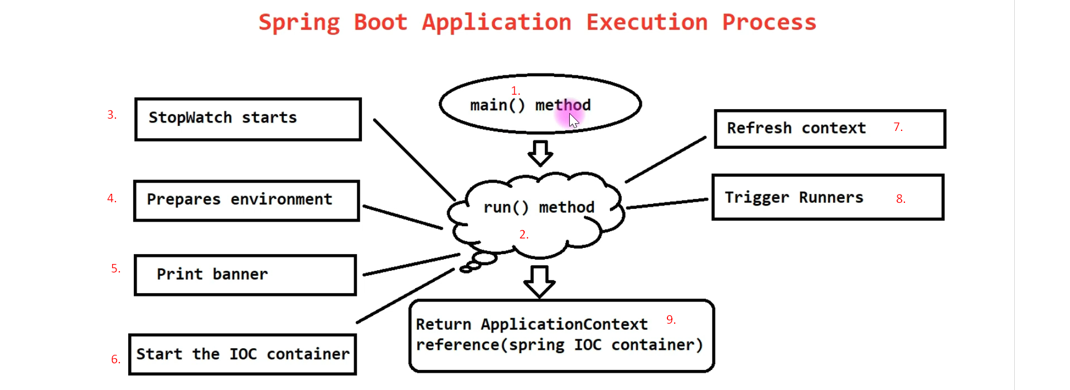
3. 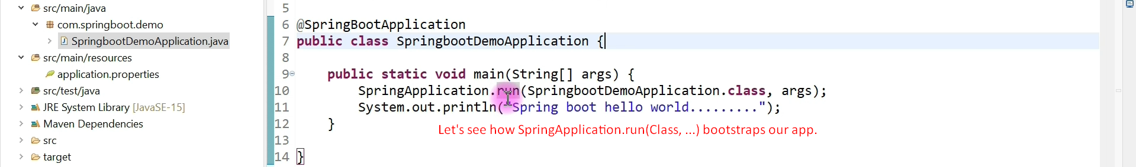  
   **Bootstrap means**:
   1. It triggers the auto-configuration process.
   2. It creates Spring IOC Container.
   3. Then it deploy our app in embedded tomcat if it is web.
4. 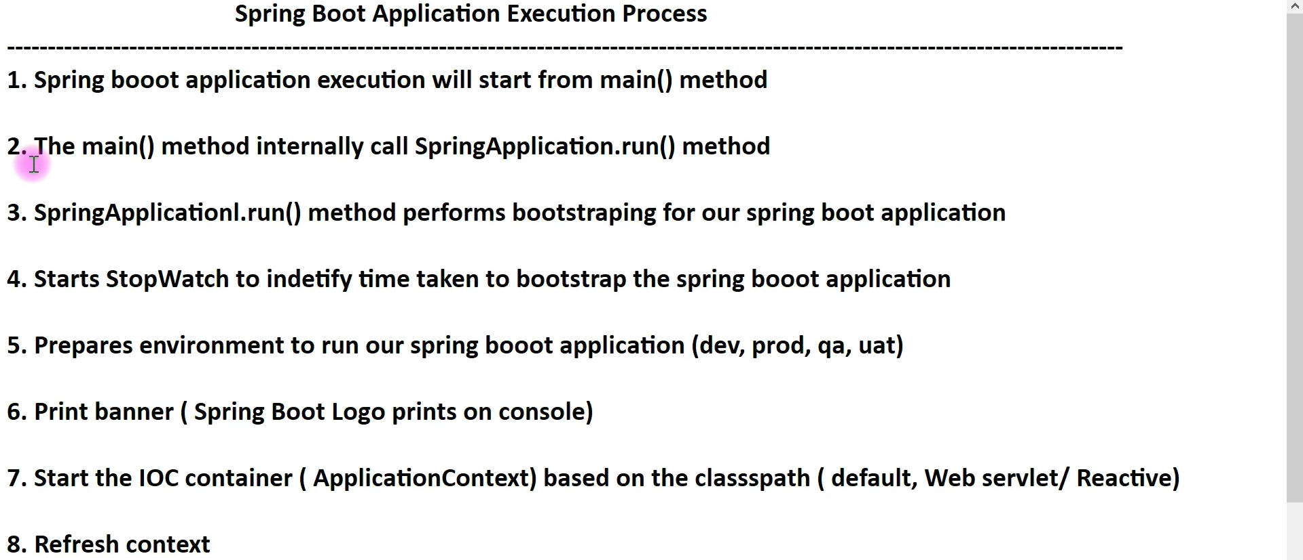  
   We can customize the default banner or disable it totally.
5. Let’s deep dive into the code to understand the internal working of bootstrapping the Spring Boot App.
   1. 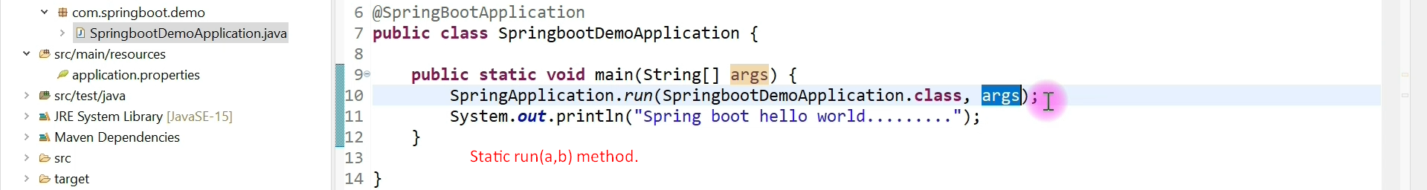
   2. 
   3. 